**Specialized Kazakh school-gymnasium named after Abai**

**Lesson plan**

**Theme of the lesson:** Natural reserves around the world

|  |  |  |  |
| --- | --- | --- | --- |
| **Unit** 6: | | **The natural world** | |
| **Teacher name:** | | **Kushchugulova Laura Shalqarqyzy** | |
| **Date:** | | **09.02.2024** | |
| **Grade: 8** | | **Number present:** | **absent:** |
| **Lesson title** | Natural reserves around the world | | |
| **Learning objectives** | 8.1.6.1 organise and present information clearly to others  8.3.7.1 use appropriate subject-specific vocabulary and syntax to talk about a range of general topics, and some curricular topics | | |
| **Lesson objectives** | **Learners will be able to:**  - To introduce the topic, to predict the content of the text, to listen for specific information | | |
| **Value links** | Integrity – Integrity is the quality of having strong moral principles. So, a person with integrity will always act with honesty and adhere to their own moral code regardless of what others do. | | |
| **Plan** | | | |

|  |  |  |  |  |
| --- | --- | --- | --- | --- |
| Stages / Time | Teachers actions | Students actions | Assessment criteria | Resources |
| Beginning of the lesson  Warming-up    *3 min*  *Pre-learning*  *«Brainstorming» method*  7 min. | **Organization moment :**  1.Greeting.  Ask about the weather.  The teacher sets the lesson objectives, letting students know what to anticipate from the lesson.  **Warming up**  How many students are there in class?  What day of the week today?  Revise the language of the previous lesson.  Teacher divide 2 groups using cards.  ***Lead – In***  https://yt3.ggpht.com/y7qv1_xT0pGSc1SMifluaffJXmqqomwICEuBhz-yiLKJqVtP5PJrgR9TdM03yRXilK-RcO-x=s88-c-k-c0x00ffffff-no-rj | **The aim:** To develop pupils speaking skills and create friendly atmosphere  **Efficiency:** By wishing each other they feel better and feel the support of others  *Students of the class are listed.*  *Students' attention is drawn to the lesson.*  Students are dividing 2 groups using cards.  • Learners write the numbers from previous lesson  *Determines the topic and purpose of the lesson*  *Students say different words from the picture* | The teacher to assess learners for their ability.  “Good job!  Well done!”  *Formative Assessment*  https://coolsen.ru/wp-content/uploads/2022/02/52-20220208_175523.png  *Good job!*  **Descriptor:**  -know key phrases  - can make sentence  - know vocabulary of previous lesson  Total: 1 point=1 coins  **Assessment criteria**  - Learners have met the learning objectives if they can: To talk about places of nature beauty | *Pictures*  *cards*  *slides*  *worksheet*  *Student’s book* |
| Middle of the lesson  Presentation part.  30 min | consolidation of learned words 6a-d module words with method of Tarsia  **Ex:1 P:71**  • Ask Ss to read the introduction and look at the pictures.  • Ask Ss to guess which of the plants and animals can be found in each place.  -read the new and give the game «who am I»  • Play the recording. Ss listen and find out.  Teacher give the text with method Jigsaw  **Ex: 2 a P: 71**  • Read the sentences aloud one at a time and ask Ss to read the texts again and correct them.  **Ex: 2b P: 71**  • Give Ss time to read the texts again and find the words.  • Check Ss’ answers.  **Ex: 3 P: 71**  • Ask Ss to work in pairs and ask and answer questions about the two nature reserves.  • Monitor the activity around the class.  **Conclusion** during the lesson some tasks differentiated by outcomes of the students and by their abilities.  Teacher is counting coins and congrates both teams. | Consolidation of learned words 6a-d module words with method of Tarsia  Pupils read the introduction on the webpage and look at the picture. Answer the question.    -repeat the new words after the teacher and learn them during the game «who am I»  **ANSWERS**  Loch Lomond – bluebells, ransoms, red deer, red squirrels, wallabies Korgalzhyn Nature Reserve – roe deer, lynx, elk, moss, lichen, mushrooms, flamingos  Pupils read the text with method Jigsaw and correct the statements  **ANSWERS**  1 In the spring, the forests around Loch Lomond are full of bluebells and ransoms. 2 Lock Lomond is famous for its fantastic wildlife and woodland. .  3 The Korgalzhyn Nature Reserve covers more than half a million hectares.  4 The star attractions of Korgalzhyn are the greater flamingos.  Pupils find the words.  **ANSWERS**  habitats: woods, wetlands, lake  types of birds: golden eagle, fish eagle, pelican, Siberian white crane, greater flamingo other types of animals: deer, red squirrel, red-necked wallaby, roe deer, lynx, elk plants: bluebells, ransom, moss, lichen, mushroom  Pupils ask and answer questions about the two nature reserves.  **ANSWERS**  A: Where is Loch Lomond?  B: In the west of Scotland. What is it famous for?  A: Its fantastic wildlife and woodlands. What plants and animals can you see there?  B: Bluebells, ransoms, deer, red squirrels, and maybe the golden eagle as well as red-necked wallabies. When were the wallabies brought there?  A: Over 70 years ago. etc | **Descriptor:**  - read the introduction  - answer the question.  Total: 1 point  C:\Users\Evrika\Downloads\WhatsApp Image 2023-12-30 at 13.05.19 (2).jpeg  **Descriptor:**  **-** read the text  - correct the statements  Total: 1 point  **Descriptor:**  - read the texts  **-** find the words  Total: 1 point  **Descriptor:**  - ask and answer questions  Total: 1 point  -Make CCQ questions Yes / No | Описание: Описание: Картинки по запросу бас бармақ әдісі  Card  Worksheet  Students book  Chocolate coins  Phones  dictionaries |
| End of the lesson  5 min | **FEEDBACK**  Learners provide feedback on what they have learned at the lesson.  **Ex:**  Home task: ex 4 p 71 and learn 6e module words | https://fsd.multiurok.ru/html/2019/04/16/s_5cb4fbdf51106/img11.jpg | | Poster Success  Описание: ÐÐ°ÑÑÐ¸Ð½ÐºÐ¸ Ð¿Ð¾ Ð·Ð°Ð¿ÑÐ¾ÑÑ ÑÐ°Ð¿Ð°Ð»Ð°Ò ÑÐ¾ÑÐ¾ |

**The ninth of February**

**Unit** 6: **The natural world**

Slide 1-2. Introduction, Greetings

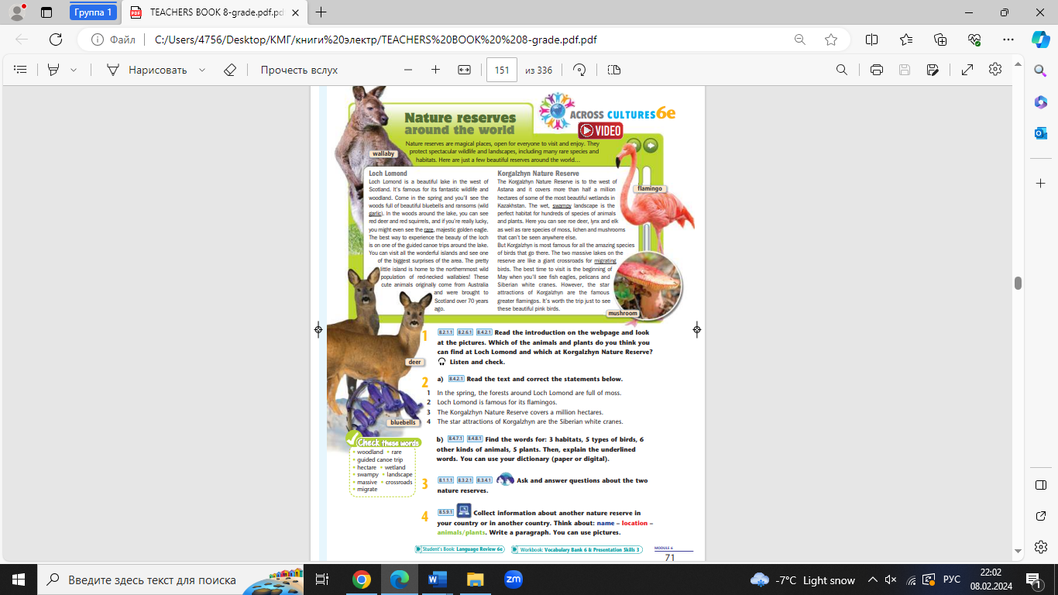 **Learning objectives**

the text with method Jigsaw



https://www.youtube.com/watch?v=iGRDclS_v1Y

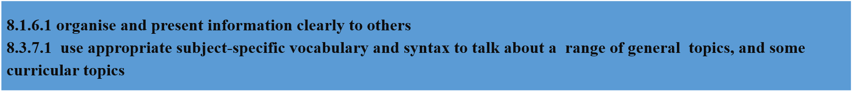



Middle of the lessonPresentation part30 min

Presentation of new words and play game «who am I»



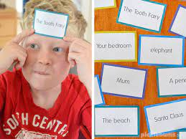

Work with 2 groups



**FEEDBACK**

Learners provide feedback on what they have learned at the lesson.

**Ex:**

Home task: ex 4 p 71 and learn 6e module words

