Specialized Kazakh school-gymnasium named after Abai

Lesson plan

Theme of the lesson: Learning about professions

Unit: 4 |  |  | Title: Professions and ways of Communication
Teacher name: |  |  | Dauriya Nurlanovna Sairan
Date: |  |  | 28.11.2023
Grade: 4 |  |  | Number present: |  |  | Number absent:
Learning objectives | 4.1.1.1 understand a wider range of instructions for performing activities in the lesson;  - recognize, identify and pronounce more words in the text with support
Lesson objectives | - understand speech on the given topic  - talk about 7 professions from the text in 4-5 sentences
Procedure of the lesson
Stage/planed things | Planed activities/teacher |  |  | Planed activities/student |  |  | Assessment | Resources
Beginning of the lesson  Warming-up  Lead in  10 min | Greetings  -Good morning boys and girls. I am glad to see you. How are you today?  -There are 2 flowers. You need take one petal, show what is on paper, read the word and divide into two groups.  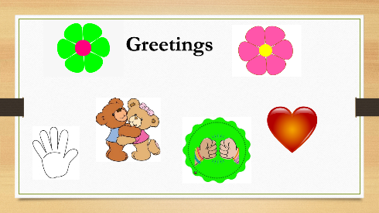  Warm up: tongue twister.  -Now, have a look at the active board. Let’s read the tongue twister. First, I will read the tongue twister then you will read it together with me and individually.  [b] [t]  The batter with the butter is the batter that is better!  Presentation of the lesson  -Watch the video and name what the topic of our lesson?   |  |  | Students greets the teacher and answer the questions.  Students take the petal, show what is on paper, read the word and divide into two groups.  Students repeat the tongue twister after the teacher and then read it individually.  Students name the topic of the lesson  -Jobs / Professions/Works |  |  | Teacher prises students orally “Well done!”  Oral feedback and correction  Excellent/Very good / Right /Well done/Good job  Oral feedback and correction if necessary. Excellent / Very good / Right. | Cards,  Candies  Slide  Cards  Video  https://youtu.be/5PTiJU_NBuU?si=QiGdIt8DO7-
Middle  6 min  2 min  6 min  8 min  7 min | PRESENTATION OF NEW MATERIAL:  -Look at the board, there are new words.  -listen to me and repeat new words chorally and / or individually.  check Ss’ intonation and pronunciation.  New words: a postman, a shop assistant, a nurse, mechanic, a waiter, a dentist, a, an architect.  Phrases: work at a hospital / garage, / shop / office / café, post office.  designed houses, fix cars, look after sick people, bring letters, serve food and drinks, sell products  Activity 1: Listening  Open your PB p.56 ex.18. Listen and match. There is one extra job.  Activity 2: Work with text in groups.  -Now, you will work with text. Read the Amir’s email from Astana and write the missing words.  Hi. My name’s Amir. I’m fourteen years old and I love football. When I’m older, I want to play for Barcelona! Nobody else in my family plays football, but they all do very interesting professions.  My Dad works at the office. He designs houses. He is an …………..  My Mum works at a hospital. She looks after sick people. She is a 2)……  My sister works in a cafe. She is a ….  My brother works in a hospital. He treats our teeth. He is a …………  My uncle can fix cars! He is a ……  I think my aunt has got the best job. She’s works in a shop. She sells a lot of delicious food and products. She is a …….  - What about the topic?  - Can you name professions from the given text?  Activity 3: Work with cards.  G1-Fill in the gaps with words in the box.  F.ex. A postman …… letters: 1-brings  drives, helps, cooks, work,  brings, flies, protects, designs  - A postman … letters.  - My mother …a big cake.  - His father … a car.  - A pilot … on a plane.  - Teachers … at school.  - A doctor … sick people.  - A policeman … people.  - An architect …… houses.  G II- write correct answer  F.ex.1 - c  _____ 1) "drives a bus"  A. waiter B. doctor C. bus driver D. waiter  _____ 2) "teaches students in a school"  A. student B. dentist C. teacher D. bus driver  _____ 3) "sings songs"  A. singer B. firefighter C. waiter D. truck driver  _____ 4) "cooks food  A. cook B. Police officer C. student D. teacher  _____ 5) "serves food in a cafe"  A. waiter B. student C. singer D. chef  _____ 6) "takes care of teeth"  A. postal worker B. chef C. dentist D. firefighter  _____ 7) "works in a hospital and treats sick people"  A. doctor B. teacher C. student D. truck driver  _____8) "works in a post office and brings letters"  A. student B.post officer C. firefighter D. waiter  Activity 4. Individual work  I show a QR code on the screen. You should scan the QR with your phones and open the site, which has a task including a previous word.  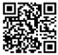 |  |  | Students repeat the new words after the teacher and then read individually.  Students listen, match and say their answers.  Students work in groups.  Students read the text and put the missing words  Students do the tasks in groups  G1 -complete the sentences correctly  -write missing words  G2 - write where people work  -use topical vocabulary  Students take out they smartphones and scan the given QR. They open the side named Wordwall and start the task. Students have to match the pictures to the words. At the end of the task, they can check their answers pressing the button “Submit answers” |  |  | Oral feedback and correction if necessary. Excellent / Very good / Right.  Oral feedback and correction if necessary. Excellent / Very good / Right.  (one smile)  Oral feedback and correction if necessary. Excellent / Very good / Right.  (one smile)  Oral feedback and correction if necessary. Excellent / Very good / Right.  (one smile)  On the given site, students can see their results. Total – 10 points | Slide  Cards with new words.  PB Smiles 4  Slide  Slide  Cards with text  Cards with task  Slide  Presentation QR,  Wardwall  Slide  
Ending of the lesson:  5 min | I’ll give you maps where you have to put objects in the right places.  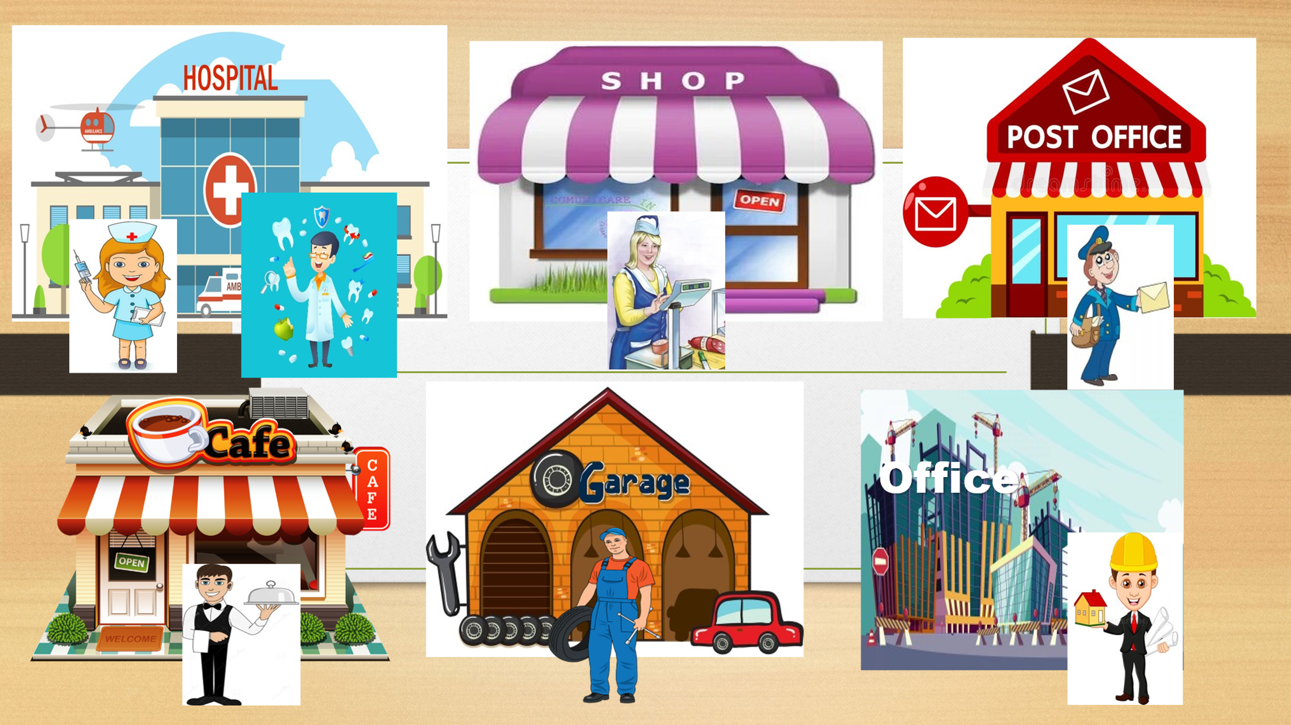 |  |  | Students put the objects on a map. Then they see on slide the right answers and tell their marks to the teacher. |  |  | Self-assessment  Feedback  Total -10 points | Presentation  Slide  Maps
Feedback  1 min | Evaluation:  I’ll give you cards, you should write your opinion: I like this lesson. It is…… / I don’t like this lesson. It is…..  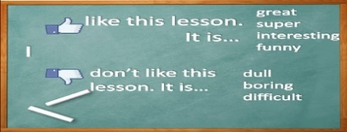 |  |  | Students write their opinions. |  |  | Feedback | Slide  Cards
Additional information
Differentiation – how do you plan to give more support? How do you plan to challenge the more able students? |  | Assessment – how are you planning to check learners  Learning? |  |  | Health and safety check
Students are given an interesting and useful video clip to understand new occupations and create positive atmosphere. |  | Criteria- based assessment.  Students were given definite criteria at the beginning of the lesson.  Groups evaluate each other on the table of assessment given at the beginning of the lesson after each task. |  |  | Health saving technologies.  Using physical exercises and energizing activities through dancing and singing with the help of a useful song.
Reflection |  | All the learners can understand and use a limited range of  The lesson objectives were formed according to the learning objectives. It will help to achieve the installed learning objectives, and help learners achieve formed lesson objectives, as all the used methods were well planned and effectively differentiated.
Summary evaluation
What two things went really well (consider both teaching and learning)?
1: Video resources or pictures help to lead – in the theme and motivate learners.
What two things would have improved the lesson (consider both teaching and learning)?
1: Clear and correct audio resources
2: More acting and role- playing
What have I learned from this lesson about the class or individuals that will inform my next lesson?
Group work helps most shy learners work out the tasks asking for support from others.

Slide 1. Introduction

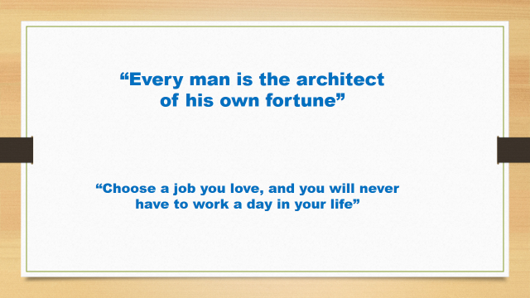

Slide 2. Greeting

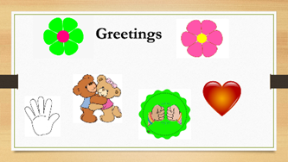

Slide 3. Warming up

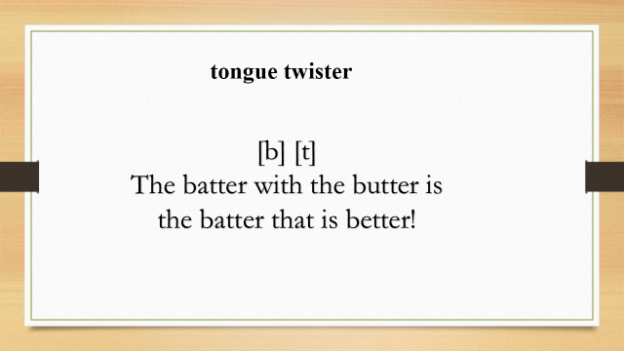

Slide 4.Presentation of the lesson

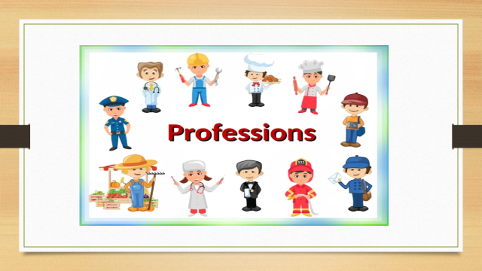

Slide 3. Warming up

Slide 5. Presentation of new words

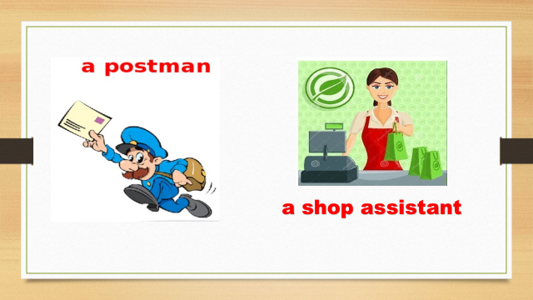

Slide 6

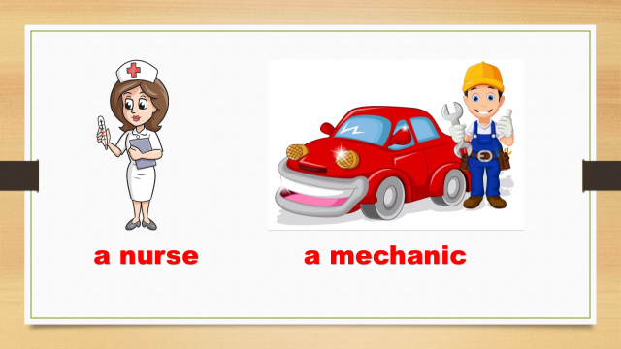

Slaide 7

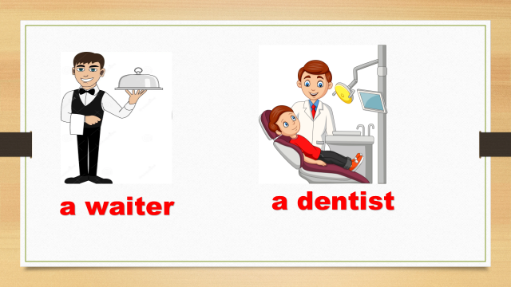

Slide8

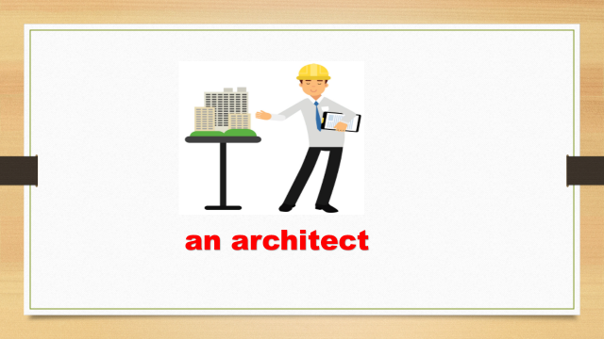

Slide 9

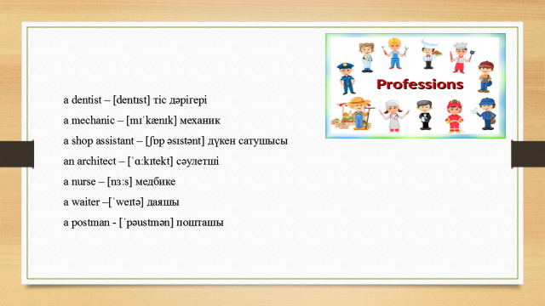

Slide10

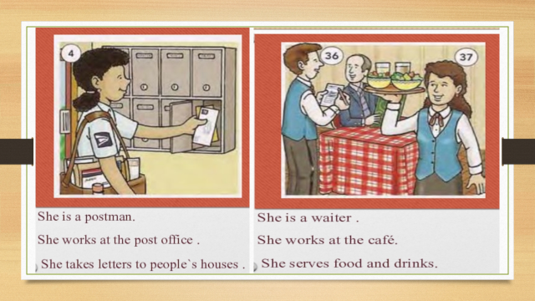

Slide 11

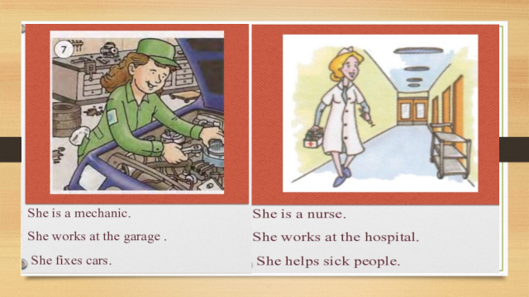
Slide 12

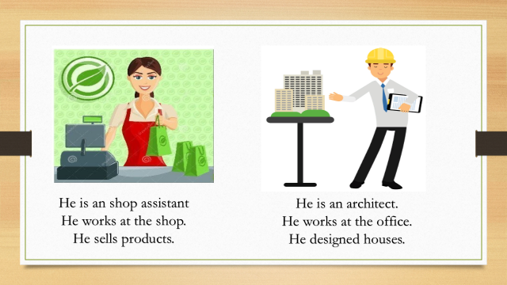

Slide 13

Slide 13
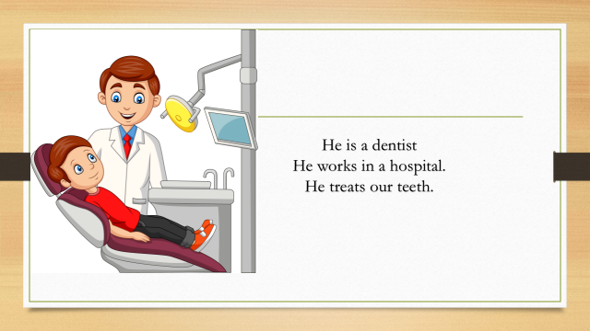

Slide 14. Task 1.Listening

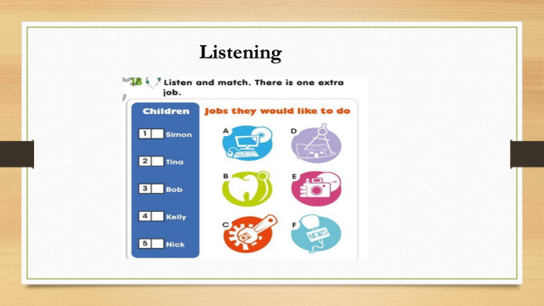

Slide 18. Individual work

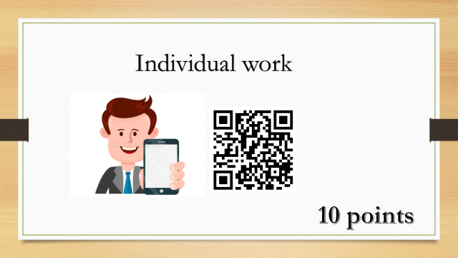

Slide 19.Work with poster

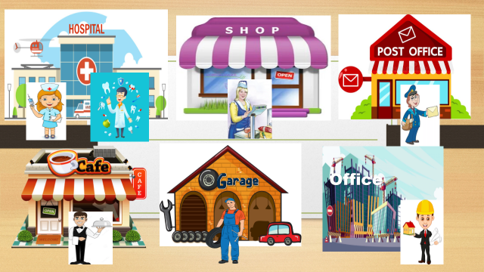

Slide 20. Feedback

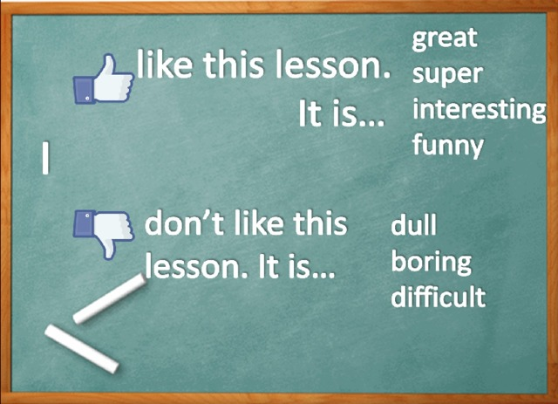

Slide 21.



